(1)

[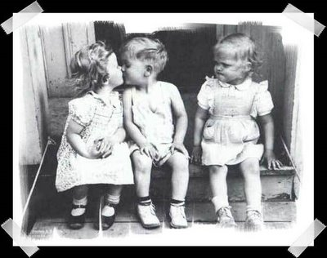](http://kingsenglish.info/wp-content/uploads/2011/02/jealous2.jpg)

 जलना तो इस काफिर दिल की फितरत है, तुम्हे किसी और के साथ  देख कर जलता है, तुम्हे कोई और देखे, तब भी तो जलता ही है | आज तक समझ नहीं पाया हूँ कि उस घड़ी का रंज करूँ या दिवाली मनाऊं जिस घड़ी तुम्हे देखा था | उसी घड़ी से आज तक दिल तिल-तिल कर जलता बुझता रहा है |  कभी लगता है कि पहले का वह आवारापन ही अच्छा था जब तुमसे नहीं मिला था, जब दिल और नज़र बस किसी पर भी आ जाते थे, और जैसे ही नज़र फेरो, दिल भी फिर जाता था | अब खूबसूरती मापने का पैमाना मिल गया है, बड़ी मुश्किल है |

पूछता हूँ, "इतना क्यूँ सताती हो?", तब मुस्कुराया मत करो, क़त्ल होते हैं !

***

 (2)

[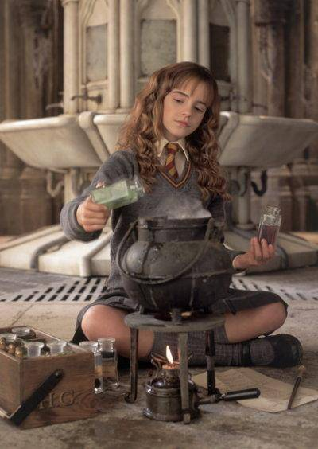](http://0.tqn.com/d/diyfashion/1/0/a/J/-/-/hermione_costume.jpg)

Some girls are like Hermione. Some say, they have an attitude problem. While the ones who have been with them for a while know that -**they** - are the solution box. Like a master key. You don’t look unto them for relationships, or maybe you might, but that is solely your discretion, but you cannot do without them. A friend at workplace, a childhood friend, or someone you just happen to know from a time you don't remember. You may or may not acknowledge it, but it is a fact that there are always some girls around you who inadvertently make your life easy as a part of their nature and not even break a sweat and would never ever talk about it. You just stand back and say, WOW.

Who says good boys end up last, even good girls do. I think it is the general class, ‘good’, that ends up last in these matters. But not for long, they are meant to lead the best lives, and be wonder (full) women, if not super women. It’s such a shame that they find it in the end, when their’s should be the first.